CREATE JAVA APPLICATION

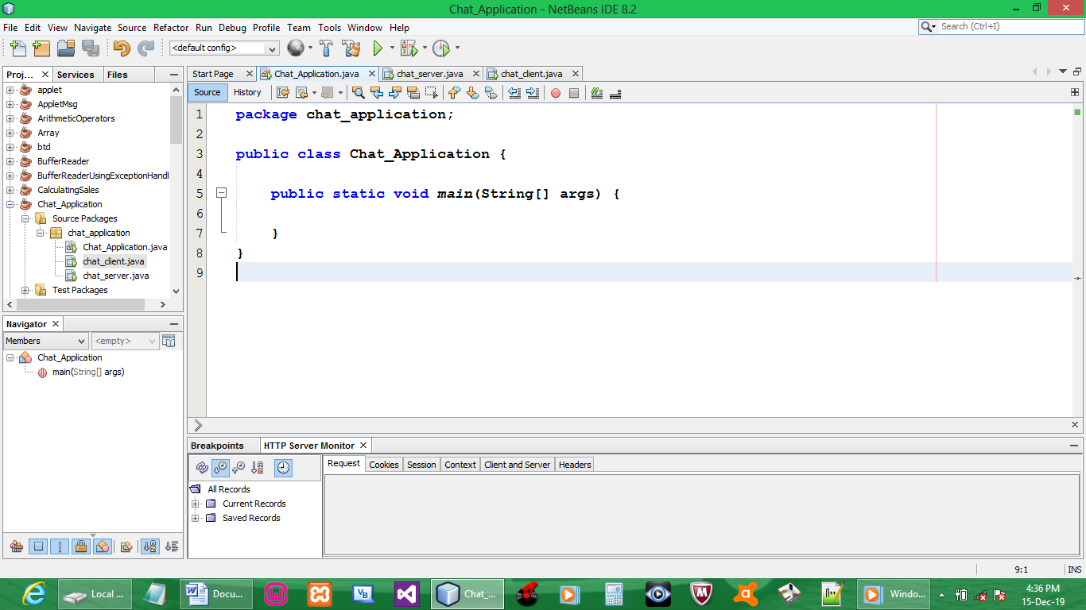

CREATE TWO JAVA FRAMES UNDER JAVA APPLICATION PACKAGE

1. SERVER FRAME AND INTERFACE

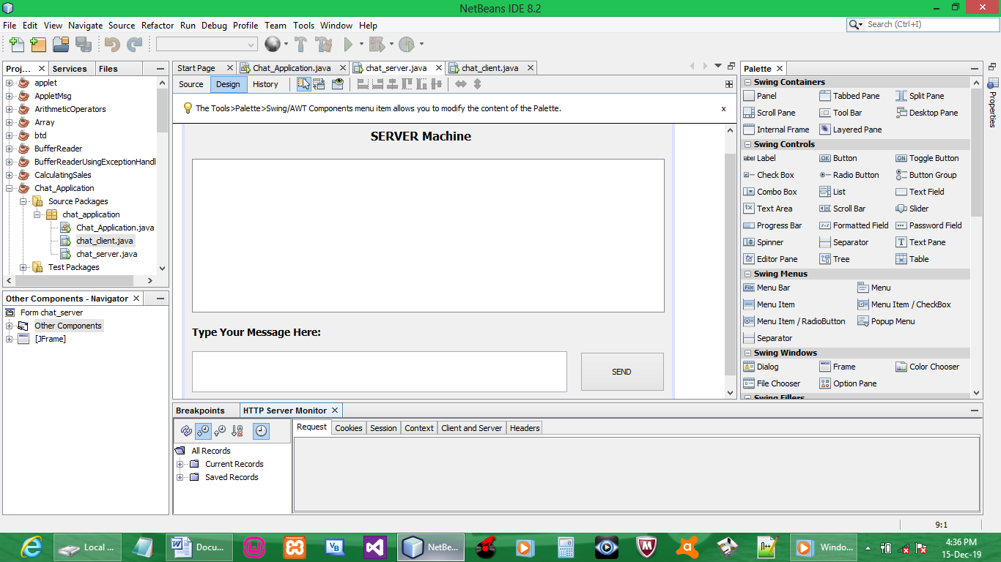

CODE:

import java.io.DataInputStream;
import java.io.DataOutputStream;
import java.io.IOException;
import java.net.ServerSocket;
import java.net.Socket;

public class chat_server extends javax.swing.JFrame {

static ServerSocket ss;
static Socket s;
static DataInputStream din;
static DataOutputStream dout;

SEND BUTTON{
try {
String msgout = "";

msgout = msg_text.getText().trim();
msgout = msgout.toUpperCase() + "\n";
dout.writeUTF(msgout);
}
catch (Exception e){

}
}

UNDER MAIN ( AFTER }(; )
try{
String msgin = "";

ss = new ServerSocket(1201);
s = ss.accept();

din = new DataInputStream(s.getInputStream());
dout = new DataOutputStream(s.getOutputStream());

while(!msgin.equals("exit")) {
msgin = din.readUTF();
msg_area.setText(msg_area.getText().trim() + "\n Client:\t" + msgin);
}
}
catch (Exception e){
}
}
2. CLIENT FRAME AND INTERFACE

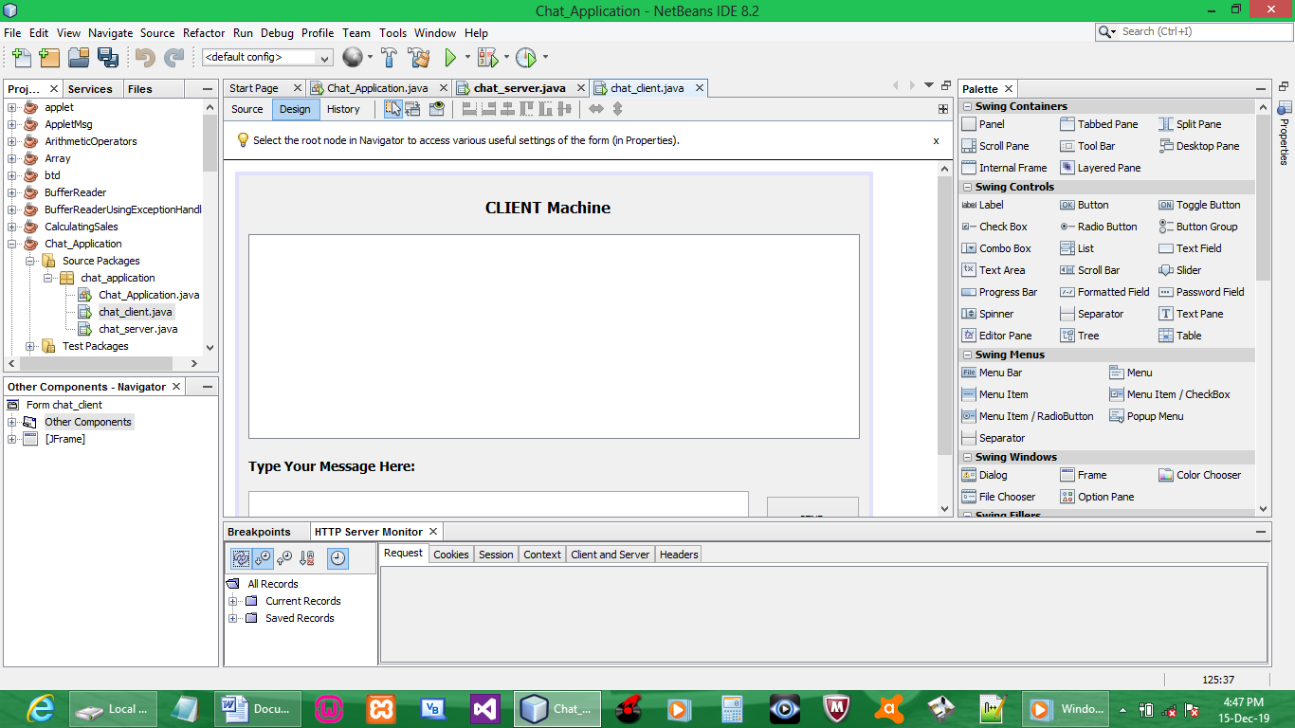

CODE:

import static chat_application.chat_server.ss;
import java.io.DataInputStream;
import java.io.DataOutputStream;
import java.net.Socket;

public class chat_client extends javax.swing.JFrame {

static Socket s;
static DataInputStream din;
static DataOutputStream dout;

SEND BUTTON{
try {
String msgout = "";

msgout = msg_text.getText().trim();
msgout = msgout.toUpperCase() + "\n";
dout.writeUTF(msgout);
}
catch (Exception e){

}
}

UNDER MAIN ( AFTER }(; )
try{

String msgin = "";

s = new Socket("127.0.0.1", 1201);

din = new DataInputStream(s.getInputStream());
dout = new DataOutputStream(s.getOutputStream());

while(!msgin.equals("exit")) {
msgin = din.readUTF();
msg_area.setText(msg_area.getText().trim() + "\n Server:\t" + msgin);
}
}
catch (Exception e){

}
}

OUTPUT:

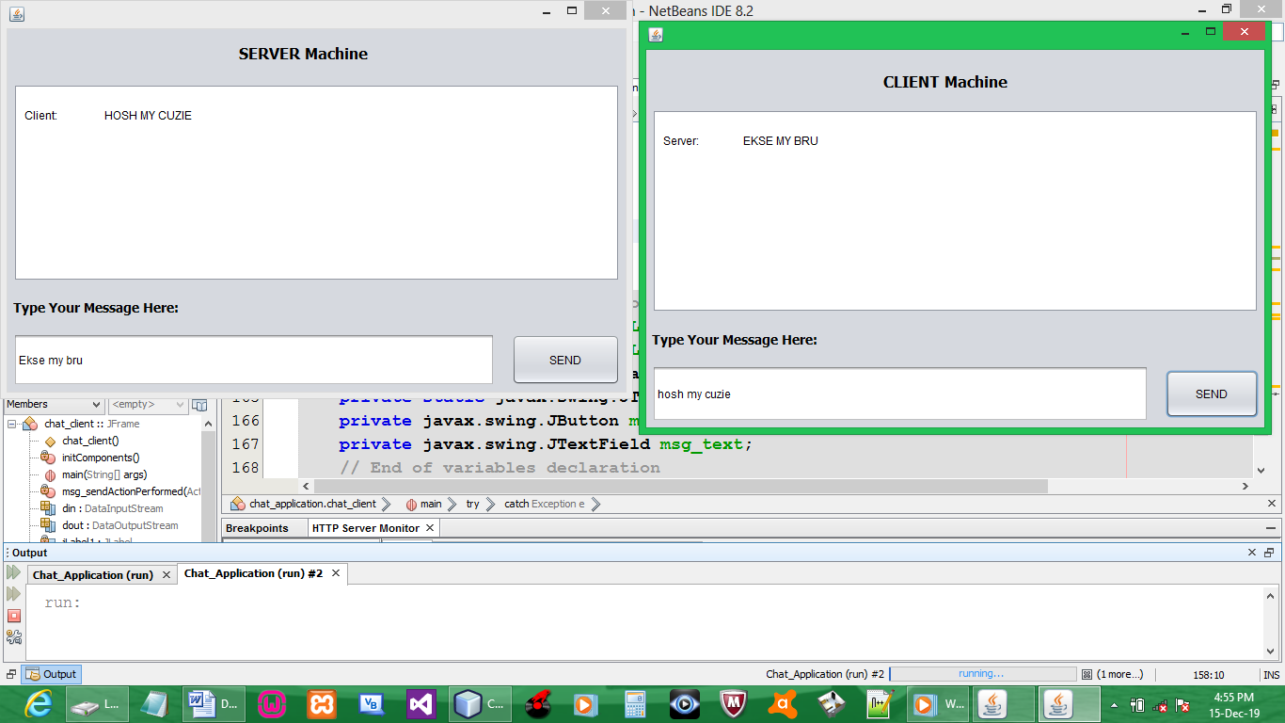

NB: message entered will be converted to uppercase. Can be changed to lower or remove completely.
NB: sender cannot see info sent to another party, can only receive info (FIX !!!)

